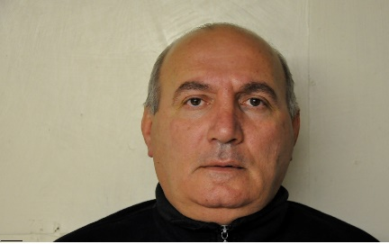
Nickoloz Javakhishvili
Date Of Birth: 12 August, 1959

WORK EXPERIENCE
JOB TITLE – Small car DRIVER 2017- 2018 Tbilisi, Georgia.

JOB TITLE- HEAVY TRUCK& BUS DRIVER FLUOR : Transportation Dept

2010 – 2013 Bagram Airfield AFGANISTAN

- Driving trucks to specified destinations

- Transporting company personal to different basis under Military convoy

- Transporting company personal from living area to work side to living area

- Delivering materials to designated places

- Assisted with loading and unloading of trucks

- Completed driver, route and gas logs

- Cleaned and maintained vehicle

- Carried out preventive maintenance tasks on a regular basis

JOB TITLE – Truck Driver Kellogg Brown & Root: Transportation Dept
2007 - 2010 Bagram Airfield AFGANISTAN

- Driving trucks to specified destinations

- Transporting company personal to different basis under Military convoy

- Delivering materials to designated places

- Assisted with loading and unloading of trucks

- Completed driver, route and gas logs

- Cleaned and maintained vehicle

- Carried out preventive maintenance tasks on a regular basis

JOB TITLE - Food Service Worker Kellogg Brown & Root:

2006 - 2007 KANDAHAR AFGHANISTAN

- Prepared a variety of food and snacks for U.S & NATO Militaries

- Served food and drinks

- Set up tables

- Chopped and marinated food items

- Cleaned equipment used for preparing food ingredients

- Wrapped and packed take away food

- Cleaned work area

- Collected payments and ringed sales

JOB TITLE - DRIVER Kellogg Brown & Root:
2004 – 2006 KRTSANISI GEORGIA

- Providing a reliable and safe transport service to U.S. Military personal.

- Maintain accurate records of journeys, fuel issues, oil , log / mileage sheets.

- Responsible for regularly checking the condition & safety of the vehicle.

- Keeping the vehicle interior clean and safe for passengers.

- Keeping operational records and making simple repairs.

- Reporting delays and accidents to controllers at head office.

- Checking a vehicles water, gas, oil and mechanical condition before driving.

- Responsible for making sure passengers are safe and comfortable at all times.

.

JOB TITLE – DRIVER-EXPEDITOR TBILISI, Transportation company#4
1982-2004 FUEL TRUCK GEORGIA.

- Maintain accurate records of journeys, fuel issues, oil, log / mileage sheets.

- Responsible for regularly checking the condition & safety of the vehicle.

- Keeping the vehicle interior clean and safe for passengers.

- Keeping operational records and making simple repairs.

- Reporting delays and accidents to controllers at head office.

- Checking a vehicles water, gas, oil and mechanical condition before driving.

- Responsible for making sure passengers are safe and comfortable at all times.

EDUCATION

GEORGIAN POLITECHNICAL COLLEGE Engineer Mechanic 1974-1979

SKILLS

- Certificate of completed HSE training
- Successfully completed first AID training
- Successfully completed OPSEC training
- Successfully completed armored vehicle driving training
- Ability to work in hostile and stressful environment - Valid Driving License B, C, D, E categories

Computer Skills

Microsoft Office - Computer literate – Microsoft Office – Word, Excel, Power point, Microsoft Outlook E-mail, Network Printers and scanners

Languages:

Georgian- NATIVE
Russian - FLUENT
English - GOOD

